**Iteration 2- Altera Design**

**Risk Analysis**

The risk analysis is assessed based on how much each requirement will affect the rest of the system and the business needs. If a use case is labeled to be high risk, it will have a higher impact on the functionality of the system and the organization itself.

high risk

* potential business value = high
* breadth of analysis = high, broad, multiple functional areas

medium risk

* potential business value = medium
* breadth of analysis = medium

low risk

* potential business value = low
* breadth of analysis = low, narrow, single functional area

During the Elaboration Phase, the requirements with the highest risk should be focused on the most. These requirements are of utmost importance since they have a high likelihood of affecting the rest of the system components and business needs. By focusing on these requirements, this ensures that design and implementation will be carried out effectively.

**Use Cases**

Use cases are used to provide a high-level view of the system to better understand its functionality. It is a simple summary of each system requirement, who it affects, and the level of risk associated with it. The risk is assigned on a high, medium, and low scale based on how much the requirement will affect the rest of the system.

**UC1- Use Case:** Backup historical data

**Primary actors:** Staff

**Description:** Create a backup of all information collected by Adelante including, donors, volunteers, grants, students and parents, financials, events, and documentation, is backed up into an accessible backup storage.

**Level:** High

**UC2- Use Case:** Centralize data

**Primary actors:** Staff

**Description:** Create a centralized database for student, donor, grant, and parent information

**Level:** High

**UC3- Use Case:** Apply to grants

**Primary actors:** Staff

**Description:** Apply to grants using relevant information extracted from database

**Level:** High

**UC4- Use Case:** Track Grant Applications

**Primary actors:** Staff

**Description:** Create and modify records of current and completed grant applications including name of grant, date applied, and accepted, rejected, or in progress

**Level:** High

**UC5- Use Case:** Track Awarded Grants

**Primary actors:** Staff

**Description:** Create and track information pertaining to awarded grants including amount received, expenditure of funds, and grantor reporting deadlines

**Level:** High

**UC6- Use Case:** Create queries and reports

**Primary actors:** Staff

**Description:** Create, modify, and delete queries and reports to show statistical information on students, volunteers, donors, etc.

**Level:** High

**UC7- Use Case:** Lookup and manipulate data

**Primary actors:** Staff

**Description:** Allow database to be easily manipulated to filter and sort data to staff’s preferences.

**Level:** Moderate

**UC8- Use Case:** Import/export Info from Cascade (JCPS)

**Primary actors:** Staff

**Description:** Import and export relevant data about student attendance and progress to and from the JCPS Cascade system

**Level:** Low

**UC9- Use Case:** Track donations

**Primary actors:** Staff and donors

**Description:** Create and modify donor information in database including personal information and amount donated.

**Level:** High

**UC10- Use Case:** Link online payments to the database

**Primary actors:** Donors

**Description:** Create and modify automated payment history into database

**Level:** High

**UC11- Use Case:** Manage student’s personal information

**Primary actors:** Staff

**Description:** Create and modify student information including start date for program, schools attended, and other relevant information

**Level:** High

**UC12- Use Case:** Link sign in system with active/inactive classification

**Primary actors:** Students and Staff

**Description:** Create and modify student attendance record to reflect inactive/active classification

**Level:** High

**UC13- Use Case:** Track student grade improvement

**Primary actors:** Cascade and Staff

**Description:** Link the database with the Cascade system used by JCPS

**Level:** Moderate

**UC14- Use Case:** Link family groups

**Primary actors:** Students, parents, and staff

**Description:** Create and modify relationships between students, parents, and siblings.

**Level:** Low

**UC15- Use Case:** Track Volunteer hours

**Primary actors:** Volunteers and staff

**Description:** Track hours and programs worked.

**Level:** High

**UC16- Use Case:** Manage Volunteer information

**Primary actors:** Volunteers and Staff

**Description:** Create and modify volunteer personal information

**Level:** Moderate

**UC17- Use Case:** Schedule volunteers

**Primary actors:** Volunteers and staff

**Description:** Create, modify, delete volunteer availability and commitment to work

**Level:** Moderate

**UC18- Use Case:** Manage Parent Information

**Primary actors:** Staff

**Description:** Create, modify, and delete records containing personal information for parents in the program

**Level:** Moderate

**UC19- Use Case:** Create progress and attendance reports for parents on website

**Primary actors:** Staff and parents

**Description:** Create, modify, and delete student progress and attendance reports for parents to access

**Level:** Low

**UC20- Use Case:** Classify contacts by category

**Primary actors:** Staff

**Description:** Create and modify contacts to be organized into groups such as parents, students, donors, and volunteers. This will allow for mass communication and enable staff to send emails to specific groups.

**Level:** Moderate

**UC21- Use Case:** Easy updates and edits to website

**Primary actors:** Staff

**Description:** Modify current website to allow staff to easily update and edit content.

**Level:** Moderate

**UC22- Use Case:** Manage calendar of events and programs

**Primary actors:** Staff, volunteers, students, and parents

**Description:** Create, modify, and delete events and program on calendar.

**Level:** Moderate

**UC23- Use Case:** Create editable and printable PDF registration forms

**Primary actors:** Students, parents, and staff

**Description:** Create PDF forms that are available on website to be printed and submitted by students, parents, and volunteers.

**Level:** Moderate

**UC24- Use Case:** Manage website to show volunteer opportunities

**Primary actors:** Staff and volunteers

**Description:** Update current website to show available volunteer opportunities

**Level:** Low

**UC25- Use Case:** Create blog

**Primary actors:** Staff and website users

**Description:** Create blog and add to website to allow staff to update others.

**Level:** Low

**UC26- Use Case:** Enable picture and video sharing

**Primary actors:** Staff

**Description:** Update and modify current website to allow easy editing and updating of pictures and videos.

**Level:** Low

**UC27- Use Case:** Request availability changes

**Primary actors:** Volunteers and Dustin

**Description:** Volunteers can edit their schedule availability which is sent to Dustin for approval

**Level:** Low

**UC28- Use Case:** Create mirror site

**Primary actors:** Staff, students, and parents

**Description:** Create and modify mirror website translated in Spanish

**Level:** Low

**UC29- Use Case:** Track event revenues and expenses

**Primary actors:** Staff

**Description:** Compile all receipts and expenditures and calculate profit/loss for the event

**Level:** High

**UC30- Use Case:** Announce events to invited guests

**Primary actors:** Staff

**Description:** Utilize contact management to inform students, parents, volunteers, donors, and community members of upcoming fundraising and outreach events

**Level:** High

**UC31- Use Case:** Track event participation

**Primary actors:** Staff

**Description:** Compile data pertaining to event attendance

**Level:** Low

**UC32- Use Case:** Create digital sign-in system

**Primary actors:** Volunteers, students, and staff

**Description:** Replace paper-based system with digital sign-in for volunteers and students.

**Level:** Moderate

**UC33- Use Case:** Link sign-in system to database

**Primary actors:** Staff

**Description:** Collect information from digital sign-in system and update or add to database

**Level:** Moderate

**Initial Architecture Considerations**

The architecture considerations must be taken into account before moving forward with the project. All options must be weighed, and the best choices highlighted. There are two viewpoints-- design and realization. Both viewpoints include system diagrams. System diagrams provide an easily understandable depiction of how a complex system works.

Design Viewpoint

This section includes a design diagram, which is a simplified representation of how the new system will function, and the components will interact. It is non-specific, identifying all the components of the Adelante system in the broadest way possible. In Adelante’s system, a user connects to the internet through their router using an internet service provider (e.g. Time Warner). From the internet, the Adelante system connects to a web server, which will host their Website. The website is organized and maintained by a Content Management System. To connect their site to their database, the web application will send requests to a Database Management System (DBMS)/Database Server. The DBMS serves as the bridge between the user/web application and the database. It creates and updates the database, and handles any requests for access to the data. To back up Adelante’s system data, the DBMS connects to the cloud, which constantly updates the information in a separate location, in case data is lost.

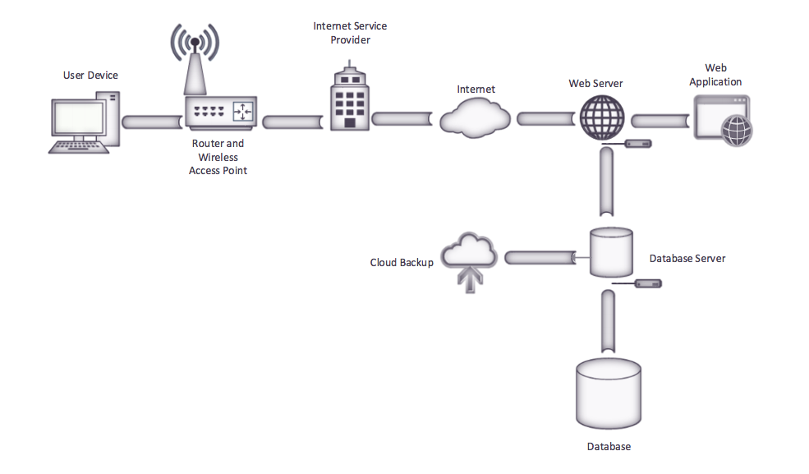

Figure 1.0: Design Viewpoint System Diagram

Realization Viewpoint

This section begins with a similar system diagram to show all components of the proposed Adelante system. However, this second diagram provides greater detail concerning the specific products that will be used to create the system. Below the diagram, there is a discussion as to why the specific products were chosen over other options.

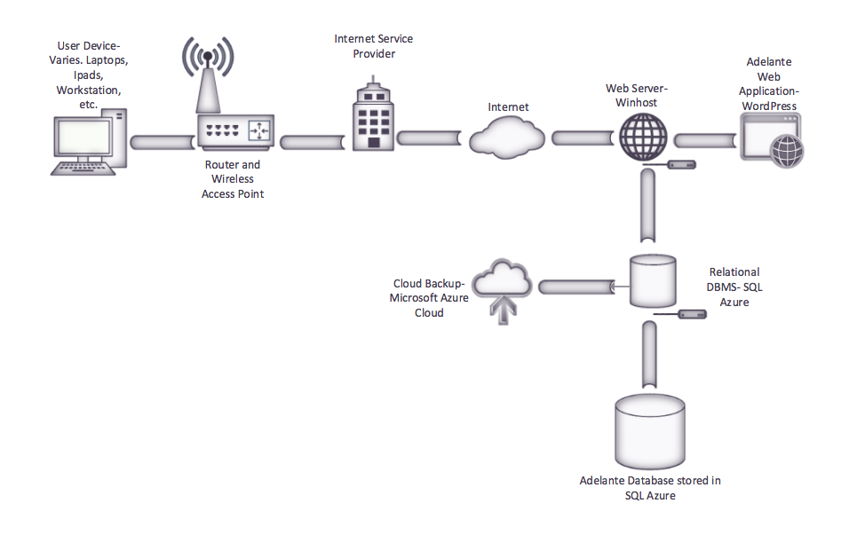

Figure 1.1 Realization Viewpoint System Diagram

Justifications

* Web server (Web hosting)
  + Chosen: Winhost
  + Reasoning: Winhost provides fair and competitive pricing for website hosting. Easy management and maintenance for staff. Clearer about what their hosting packages included, compared to goDaddy. Included unlimited website disk space and 5 GB of SQL Disk Space, which could be handy if needed in the future. Winhost has greater reliability than GoDaddy.
* Web Application Content Management System (CMS)
  + Chosen: Wordpress
  + Reasoning: While there were many great open source options, it appears that Wordpress is the best choice for Adelante. The biggest reason for this choice is Wordpress’ legitimacy and reputation as the most popular CMS available. Its high usage means that it is trusted, has a great amount of support, and has the most additional plug-ins (adds even more functionality for a website). According to their site, Wordpress powers 25% of websites. Wordpress is free, easy to use for a non-technical user, and customizable.
* Database Management System (DBMS)
  + Chosen: SQL Azure
  + Reasoning: SQL Azure is a relational database management system existing within to the cloud. According to the Microsoft website, “SQL Database is built on standardized hardware and software that is owned, hosted, and maintained by Microsoft. With SQL Database, you can develop directly on the service using built-in features and functionality.” Though it might be more than Adelante currently needs, it was chosen over MySQL. SQL Azure is most importantly secure compared to mySQL. Working with JCPS student information, security is critical. Also, SQL Azure has greater scalability compared to mySQL, and is easy to upgrade. Being native to the cloud, SQL Azure provides safe, reliable backups.

**System Requirements**

The system requirements are based on the product features section of the Vision Document to show how the system will implement these requirements. The list is organized into a hierarchy from most to least important features.

SR (1) Backup

1. The system will provide reliable backup of historical data

SR (2) Database Features

1. The system will provide for centralization of data
2. Grant tracking
   1. The system will enable efficient application to grants
   2. The system will track grant information
   3. The system will track awarded grants

3. Data Manipulation

1. The system will compile data from database for statistical analysis
2. The system will import/export excel data to/from Cascade (JCPS)
3. The system will allow creation of queries and reports
   1. The system will allow lookup and manipulation of data

4. Donor information

1. The system will track donations
2. The system will link online payments to database

5. Student Information

1. The system will manage student’s personal information
2. The system will link sign in system with active/inactive classification
3. The system will track student grade improvement
4. The system will link family groups

6. Volunteer Information

1. The system will track volunteer hours
2. The system will manage volunteer information
3. The system will allow scheduling of volunteers

7. Parent Information

1. The system will manage parent information
2. The system will create progress and attendance reports for parents on website

8. Contact Management

1. The system will classify contacts by category

SR (3) Website Features

1. The system will allow easy updates and edits to website
2. The system will manage calendar of events and programs
3. The system will allow creation of editable and printable PDF registration forms
4. The system will manage website to show volunteer opportunities
5. The system will allow creation of a blog
6. The system will enable picture and video sharing
7. The system will allow requests for availability changes
8. Create mirror site

SR (4) Events

1. The system will track event revenues and expenses
2. The system will allow announcement of events to invited guests
3. The system will track event participation

SR (5) Sign-in System

1. The system will have a digital sign-in system
2. The system will link sign-in system to database

**Trace Matrix**

The trace matrix details which system requirements complement the use cases. It is a visual representation of ensuring that each system requirement has a use case to describe it further.

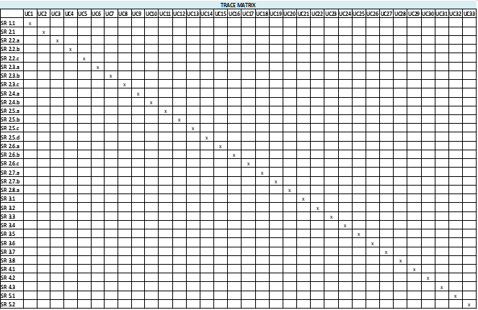

Figure 2.0 Trace Matrix

**Gantt Chart**

A Gantt chart is a breakdown of each phase of the project in terms of time and activity level. The chart begins at the first phase and takes a logical path to the end of the project at the last phase.

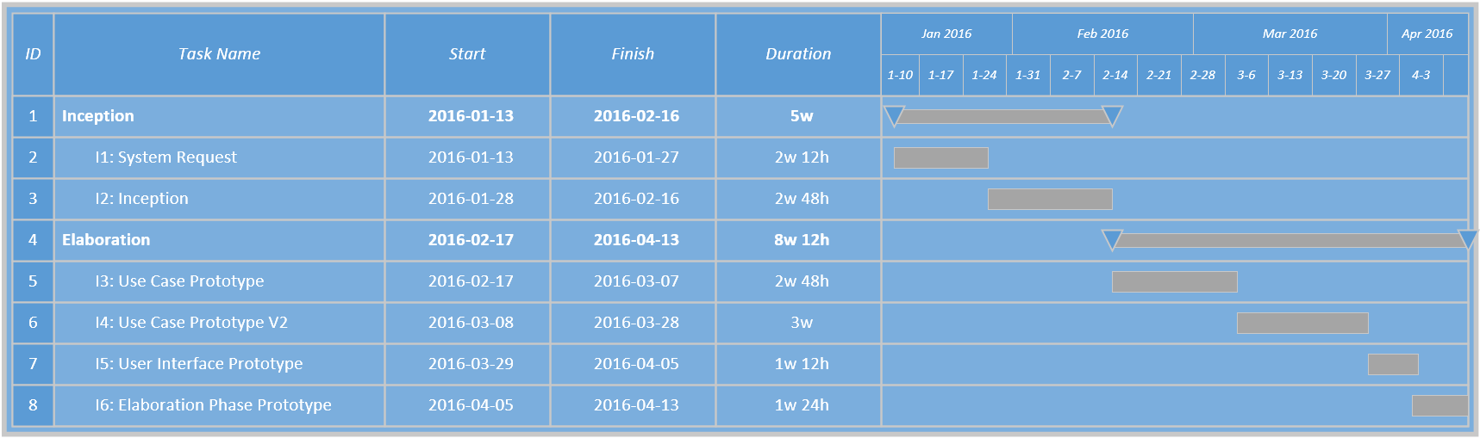

Figure 2.1 Gantt Chart

**Prototypes**

The prototype wireframes are a barebones non-functioning layout of the system functions and features. They help visualize the “to-be” system which is a representation of how the pages will ultimately be laid out.

Figure 3.0

This prototype models the layout of the Adelante website homepage

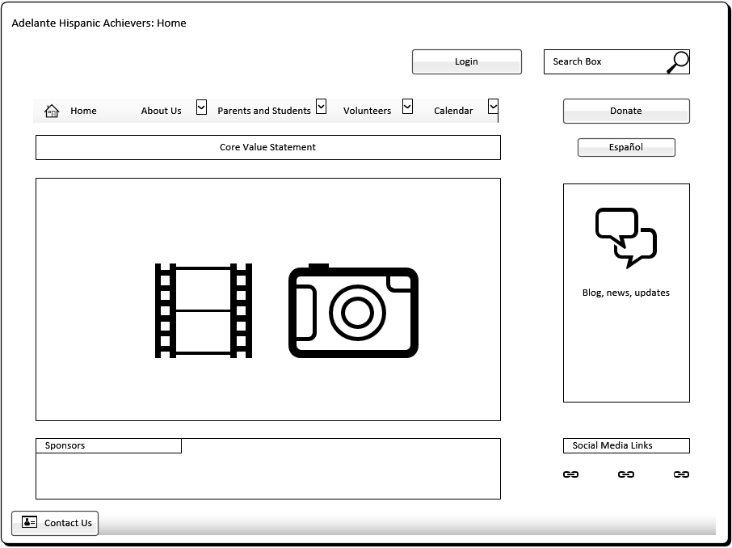

Figure 3.1

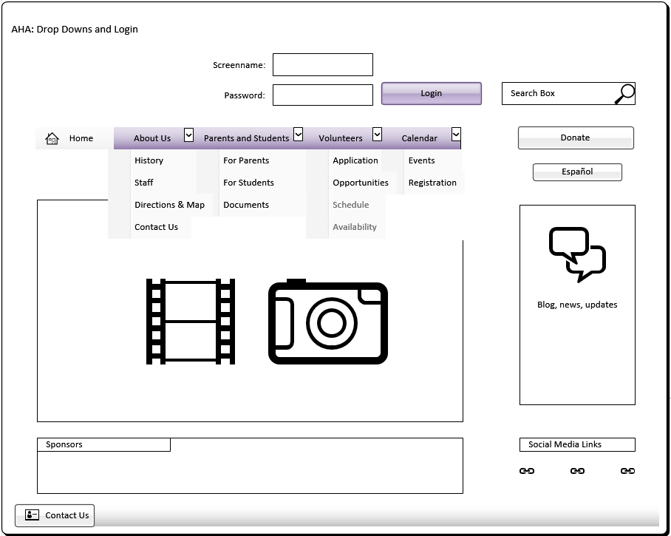This prototype shows the drop down menus of the home page and the login feature.

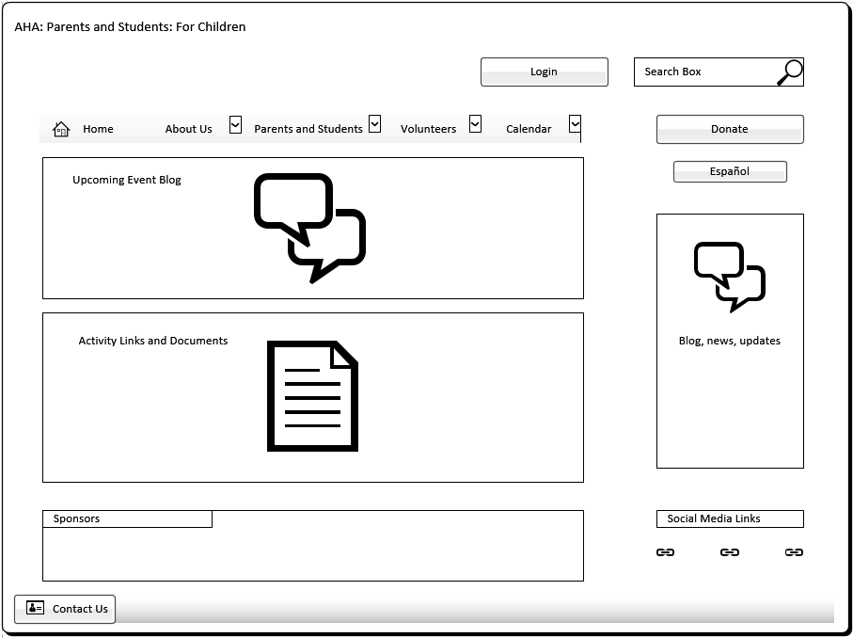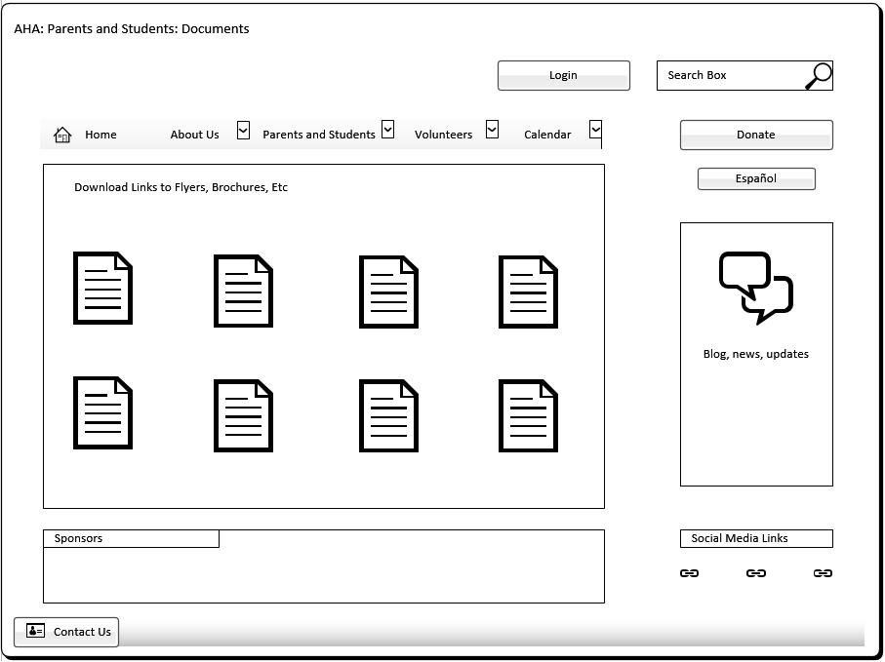Figure 3.2

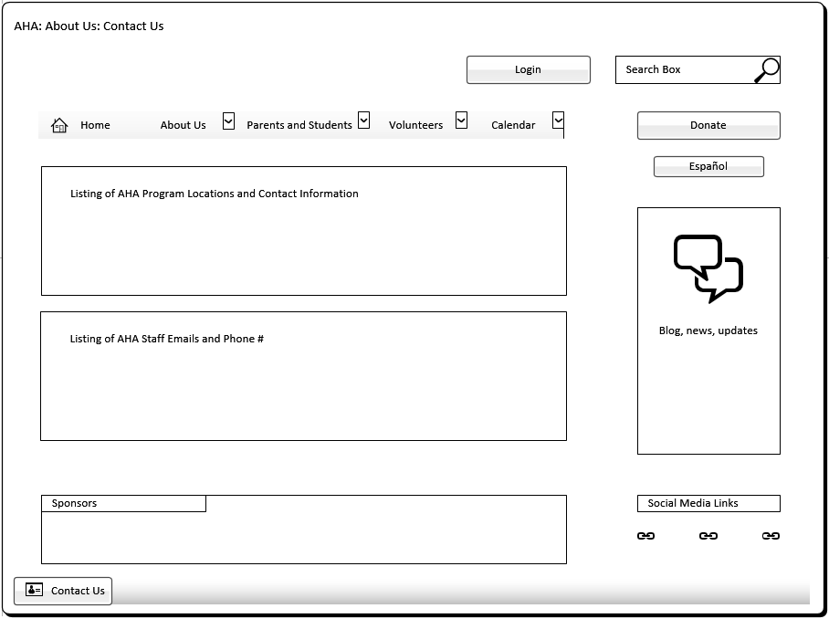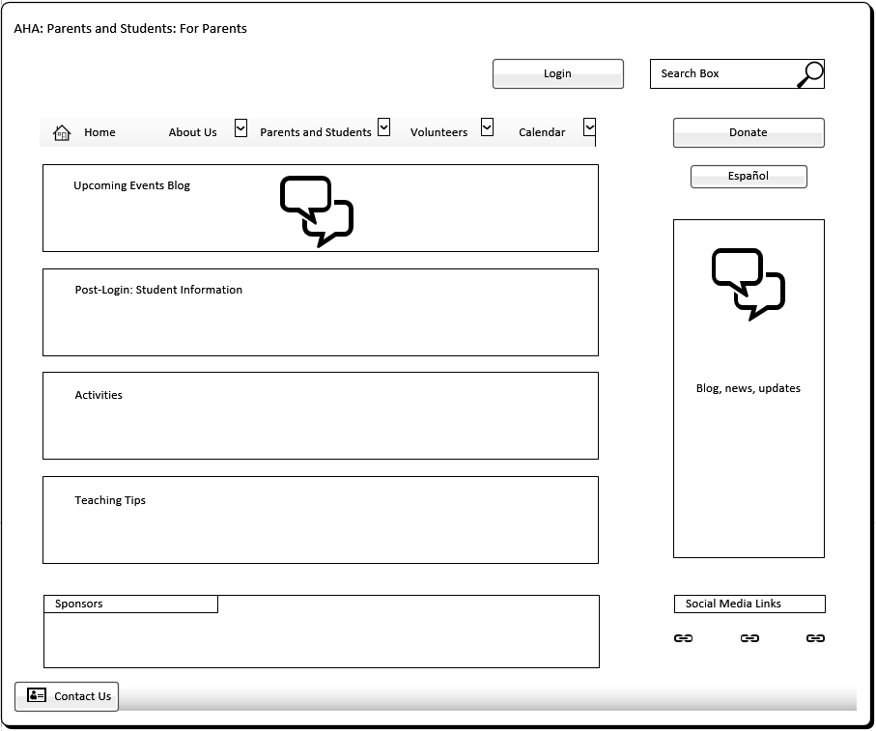

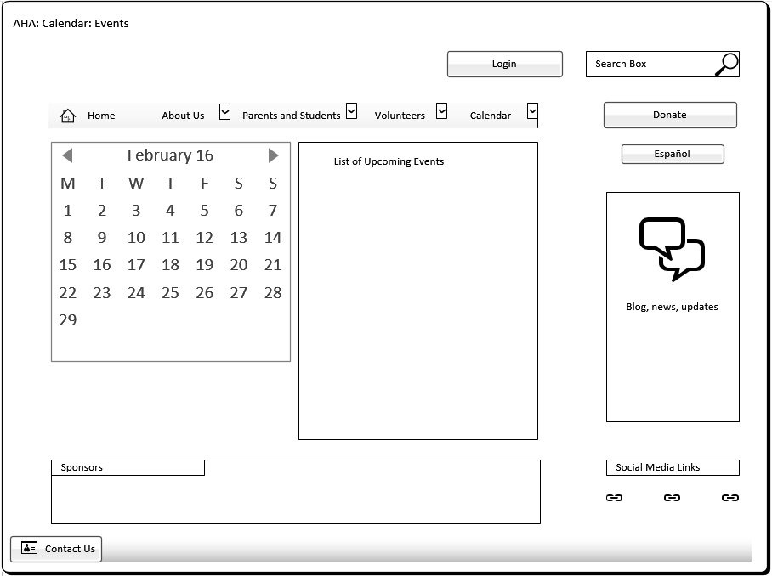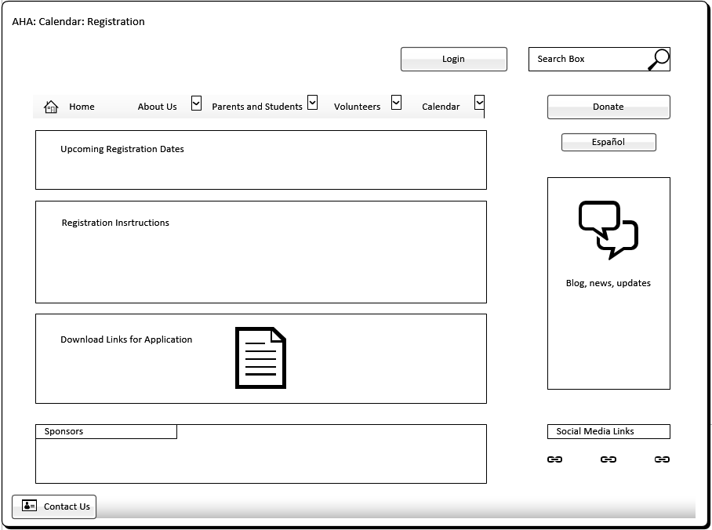

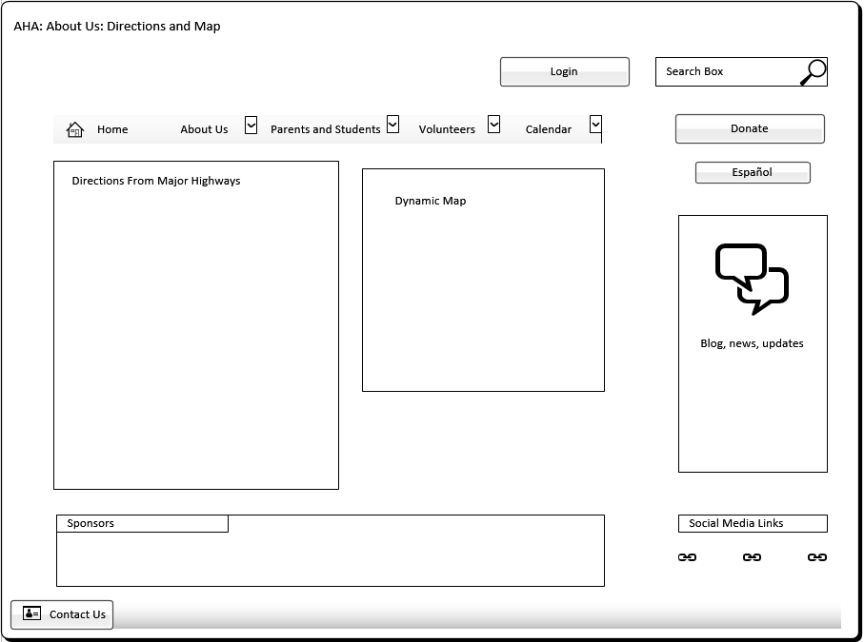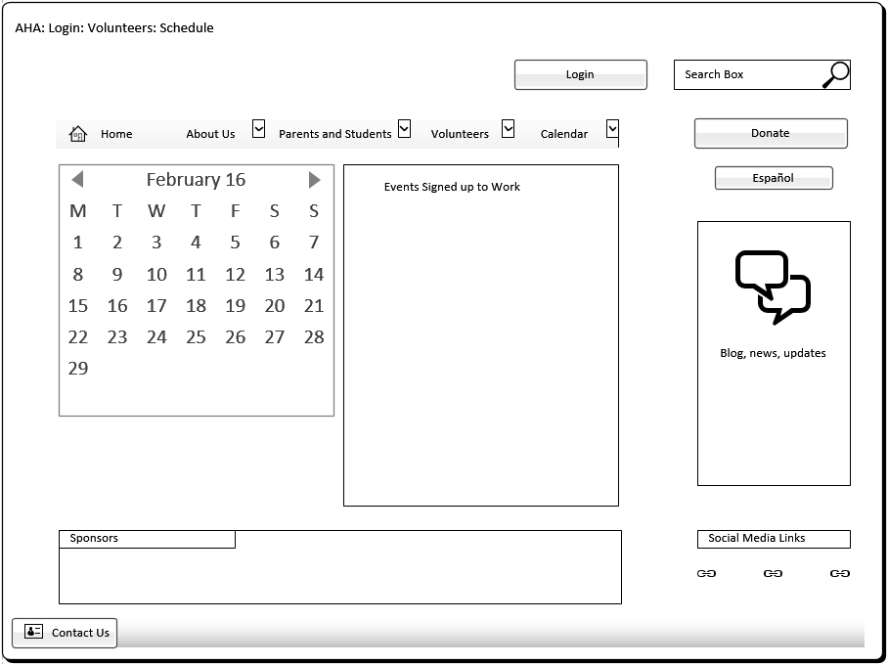

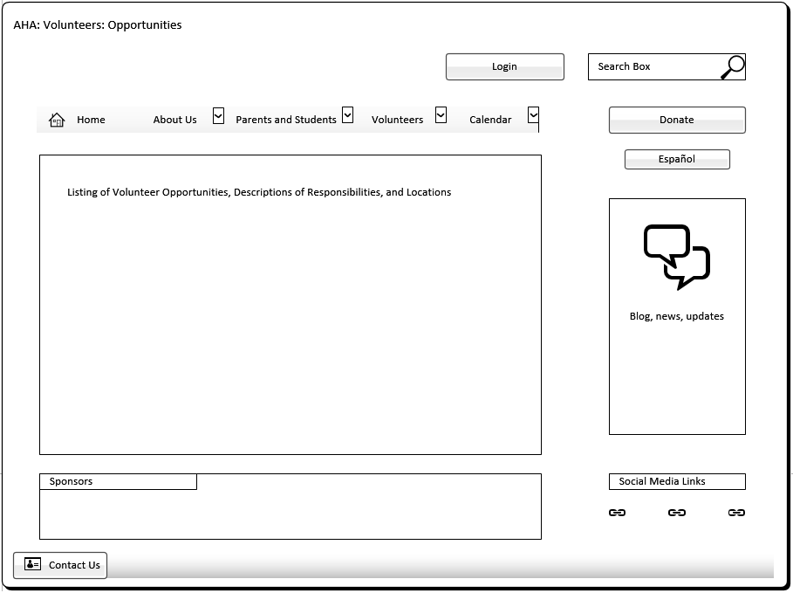

This prototype is a representation of the page for students.

Figure 3.3 This prototype model is a view of the Staff Bio page on the website 